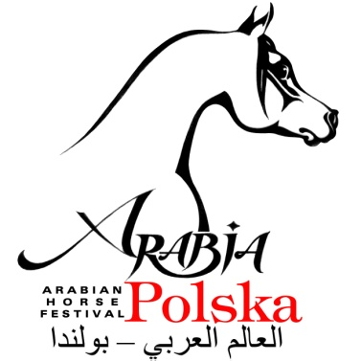 | ARABIA - POLSKA  IV Warsaw Championship  ECAHO INTERNATIONAL B-International Show  Góra Kalwaria, Buksza Polo & Riding Club, June 27-38th, 2015.  Closing date for entries: 10th of June 2015
ENTRY FORM (only one horse per form)
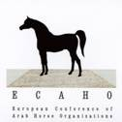

ECAHO affiliation
061/2015/pl

Owner: | .................................................................................................................... |  |  | Country: | y................................
Address: | .................................................................................................................................................................
e-mail: | ................................. | Tel./Fax: | ............................................................
Breeder: | .................................................................................................................... |  |  | Countryj: | y................................

By the closing date of entries, the horse is registered in the Studbook of |  |  |  | Country: | Studbook: | Passport no.:
Class: | Name oft the horse: |  | Sire: | Sire: | I, the undersigned exhibitor, engage that I and my servants and assistants hold entire responsibility for the horse entered and I accept without restriction the statutes, regulations and jurisdiction of ECAHO. Furthermore, concerning my entry, I agree to declare any possible conflict of interest with the judges.
 |  |  |  | Dam:
 | Date of birth: |  | Dam: | Sire:
 | Sex: | Colour: |  | Dam:
Photocopies of the presently valid registration documents are enclosed. |  |  |  |  | Name of the exhibitor:
 |  |  |  |  | …......................................................................
This Entry Form is not valid without signature  Closing date for entries : 10th of June, 2015 . Cancellations after that date will be charged !! |  |  |  |  | Date & Signature of the exhibitor:
 |  |  |  |  | …......................................................................

Please mail the Entry Form to the Show Office: MZ BUKSZA.: ul. Lipowa 5, 05-530 Obręb, Poland, or send by email to: buksza@icloud.com

Information: Paweł Olbrych mobile: +48.601.332584
All payments to Majatek Ziemski Buksza Paweł Olbrych, Lipowa 5 , 05-530 Obręb Rachunek nr 59 1240 6247 1111 0000 4976 8662
Bank PEKAO SA

